**Supplementary Material**

**PART A: MODEL FITTING**

Bayesian ordinal model fit plots were generated using the built-in brms tool pp_check (Bürkner 2018). Fitting for logistic binomial GLM plots was done using performance (Lüdecke et al., 2020) for generating binned residuals and plots ~~and see for plotting~~ (Lüdecke et al., 2020).

**Part 1: Model Fitting**

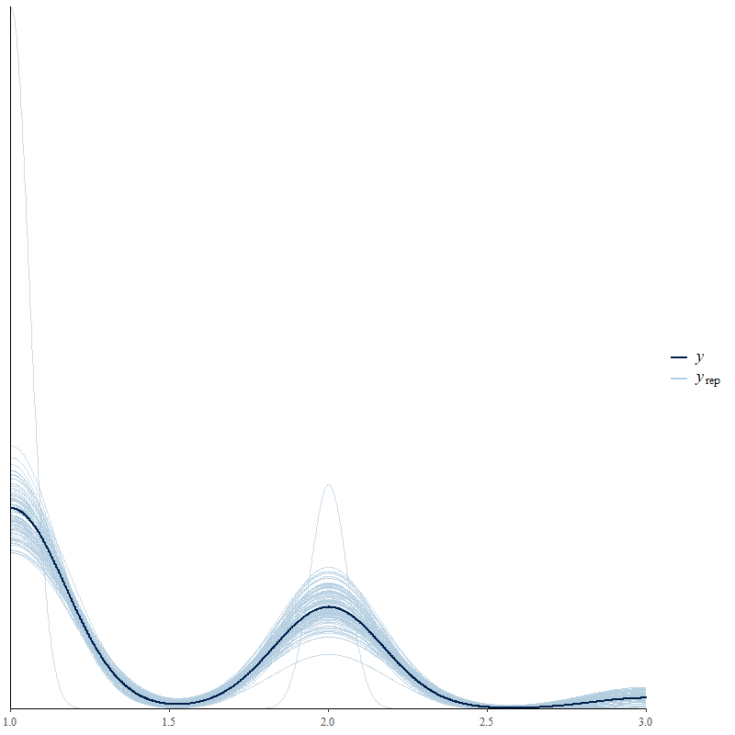

**Supplementary Figure 1.** Safety Model Plot: Observed data (dark blue line) and modelled data (light blue lines).

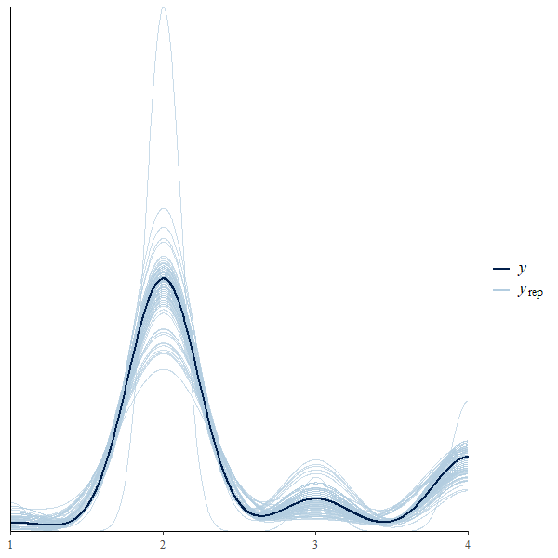

**Supplementary Figure 2.** Changes in General Safety Model Plot: Observed data (dark blue line) and modelled data (light blue lines).

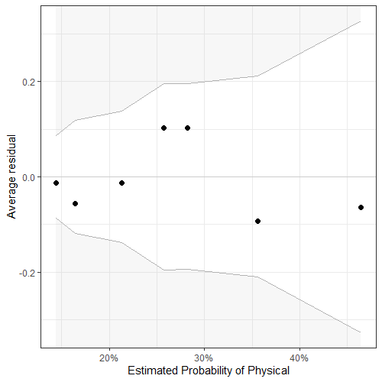

**Supplementary Figure 3.** Specific Safety Concern Physical Model Plot: About 100% of the residuals are inside the error bounds (white area).

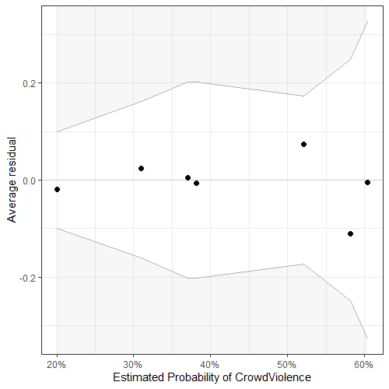

**Supplementary Figure 4.** Specific Safety Concern Crowd Violence Model Plot: About 100% of the residuals are inside the error bounds (white area).

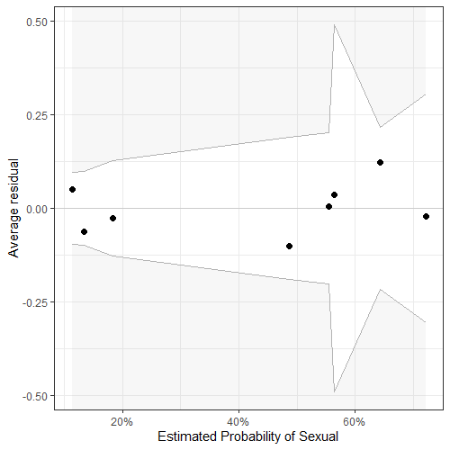

**Supplementary Figure 5.** Specific Safety Concern Sexual Model Plot: About 100% of the residuals are inside the error bounds (white area).

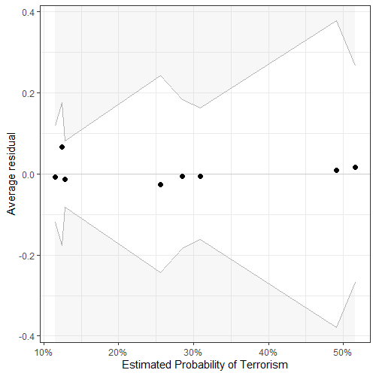

**Supplementary Figure 6.** Specific Safety Concern Terrorism Model Plot: About 100% of the residuals are inside the error bounds (white area).

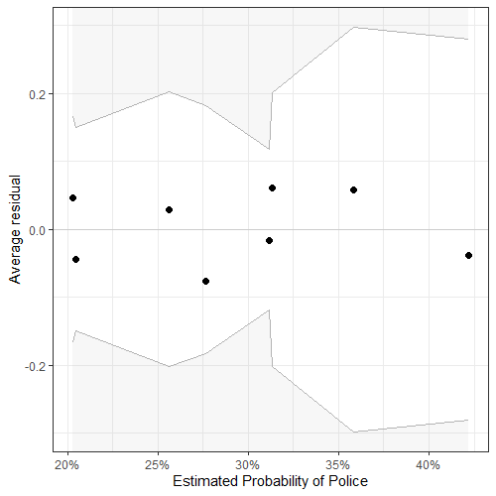

**Supplementary Figure 7.** Specific Safety Concern Police Model Plot: About 100% of the residuals are inside the error bounds (white area).

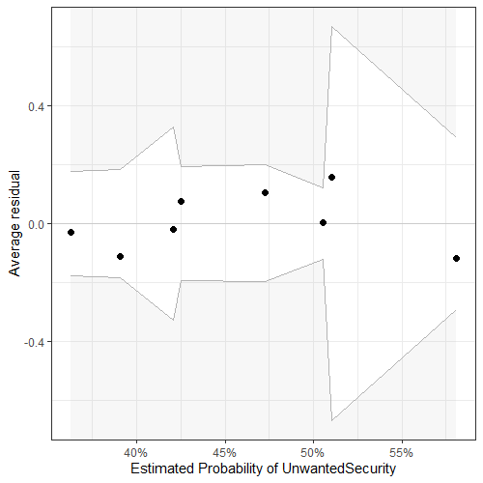

**Supplementary Figure 8.** Specific Safety Concern Unwanted Security Model Plot: About 100% of the residuals are inside the error bounds (white area).

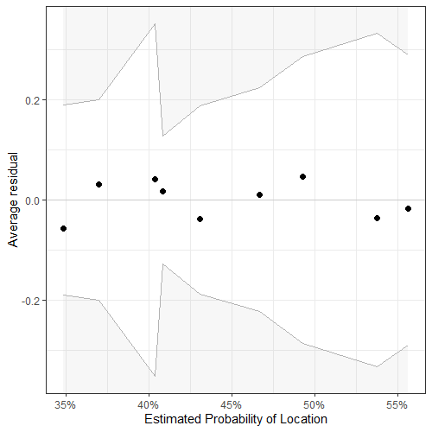

**Supplementary Figure 9.** Safety Measures Location Model Plot: About 100% of the residuals are inside the error bounds (white area).

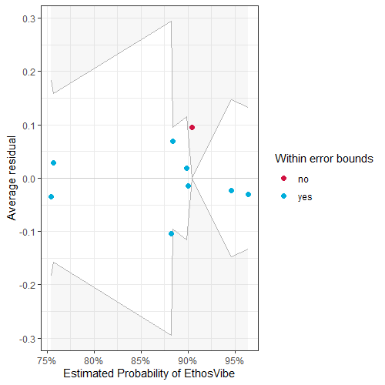

**Supplementary Figure 10.** Safety Measures Ethos/Vibe/Rules Model Plot: About 89% of the residuals are inside the error bounds (white area).

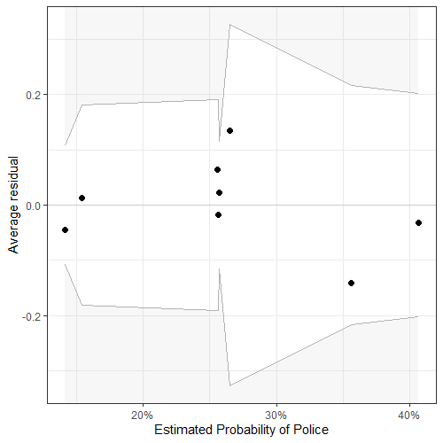

**Supplementary Figure 11.** Safety Measures Police Model Plot: About 100% of the residuals are inside the error bounds (white area).

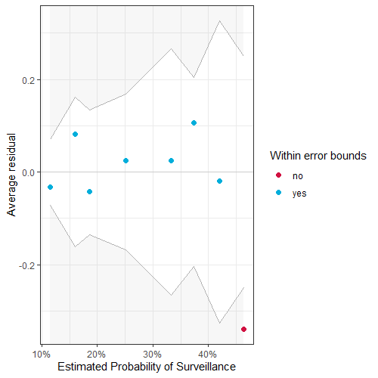

**Supplementary Figure 12.** Safety Measures Surveillance Model Plot: About 88% of the residuals are inside the error bounds (white area).

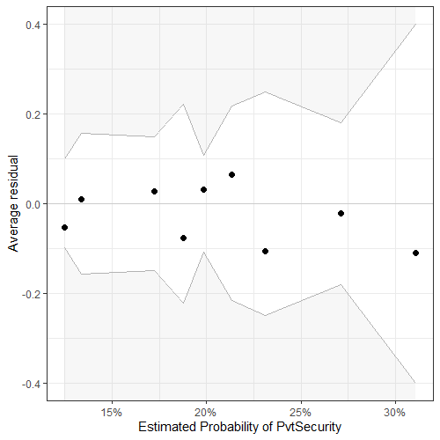

**Supplementary Figure 13.** Safety Measures Private Security Model Plot: About 100% of the residuals are inside the error bounds (white area).

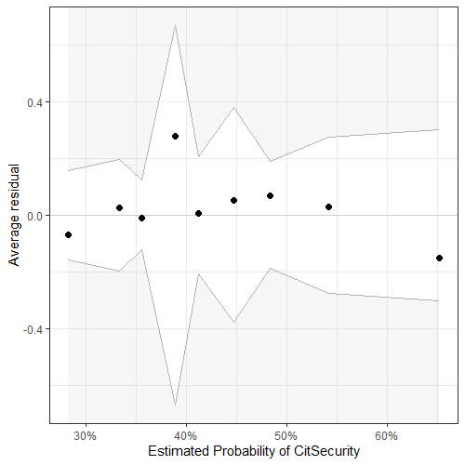

**Supplementary Figure 14.** Safety Measures Citizen Security Model Plot: About 100% of the residuals are inside the error bounds (white area).

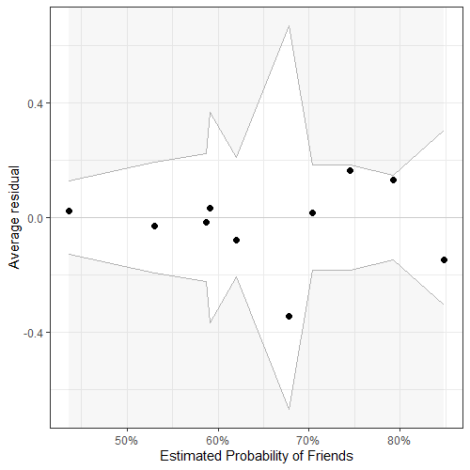

**Supplementary Figure 15.** Safety Measures Friends Model Plot: About 100% of the residuals are inside the error bounds (white area).

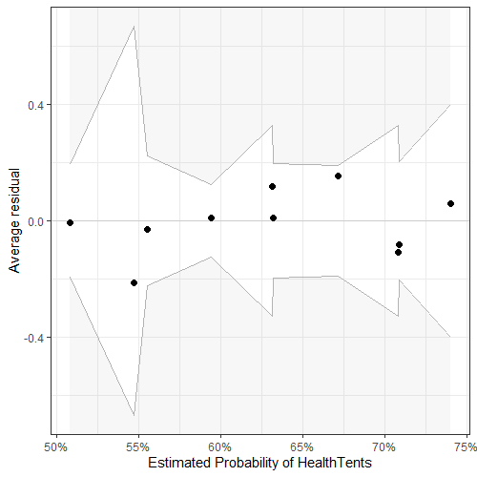

**Supplementary Figure 16.** Safety Measures Health Tents Model Plot: About 100% of the residuals are inside the error bounds (white area).

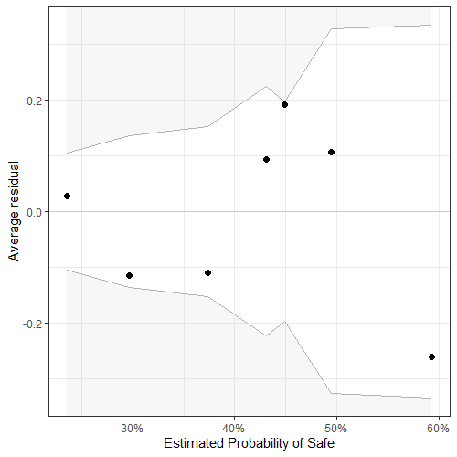

**Supplementary Figure 17.** Feelings about Surveillance Safe Model Plot: About 100% of the residuals are inside the error bounds (white area).

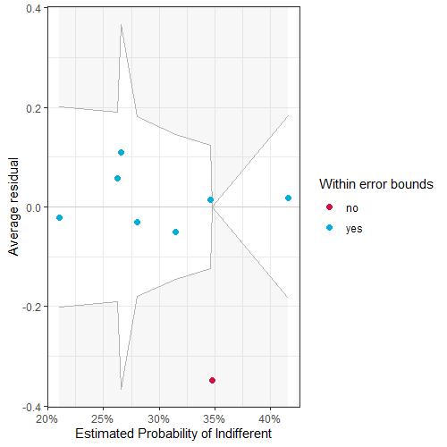

**Supplementary Figure 18.** Feelings about Surveillance Indifferent Model Plot: About 88% of the residuals are inside the error bounds (white area).

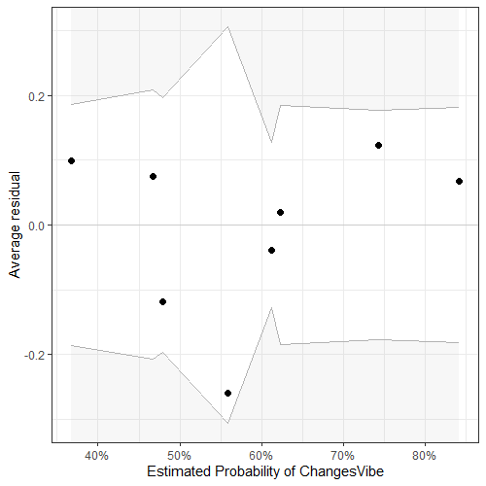

**Supplementary Figure 19.** Feelings about Surveillance Changed Vibe Model Plot: About 100% of the residuals are inside the error bounds (white area).

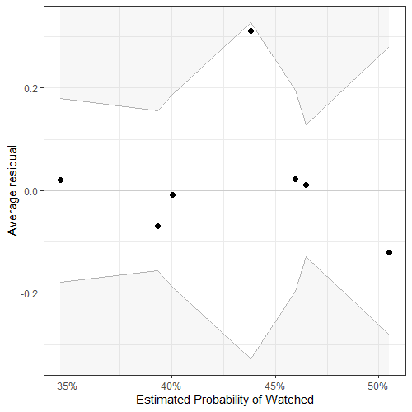

**Supplementary Figure 20.** Feelings about Surveillance Watched Model Plot: About 100% of the residuals are inside the error bounds (white area).

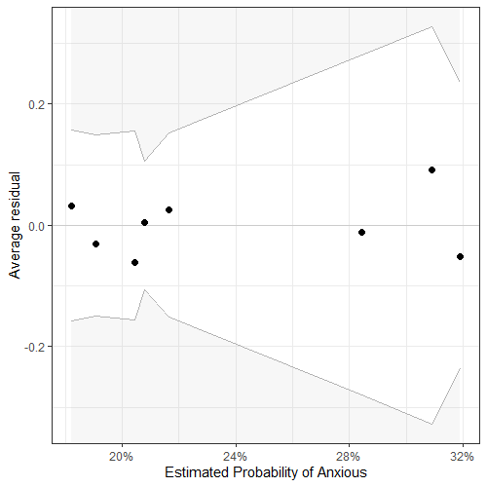

**Supplementary Figure 21.** Feelings about Surveillance Anxious Model Plot: About 100% of the residuals are inside the error bounds (white area).

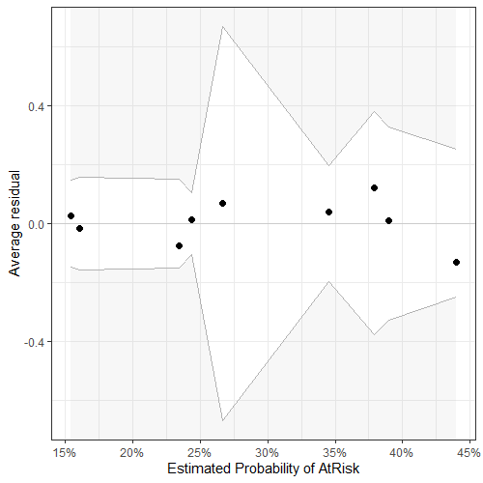

**Supplementary Figure 22.** Feelings about Surveillance At Risk Model Plot: About 100% of the residuals are inside the error bounds (white area).

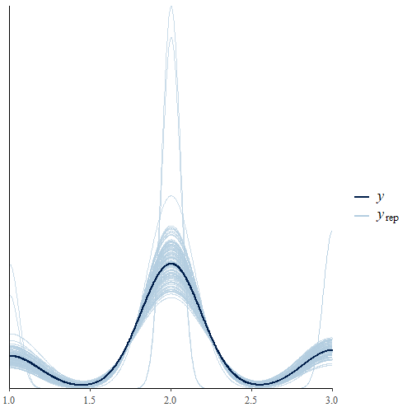

**Supplementary Figure 23.** Notice Surveillance Model Plot: Observed data (dark blue line) and modelled data (light blue lines)

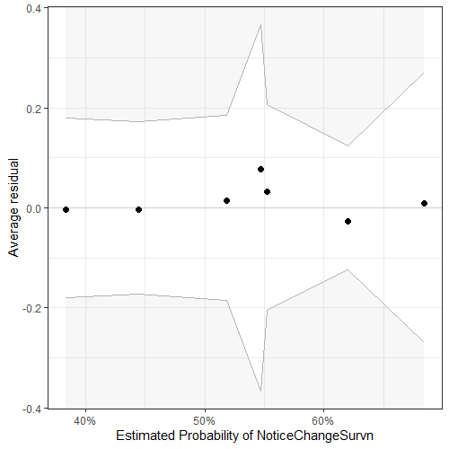

**Supplementary Figure 24.** Notice Increased Surveillance Model Plot: About 100% of the residuals are inside the error bounds (white area).

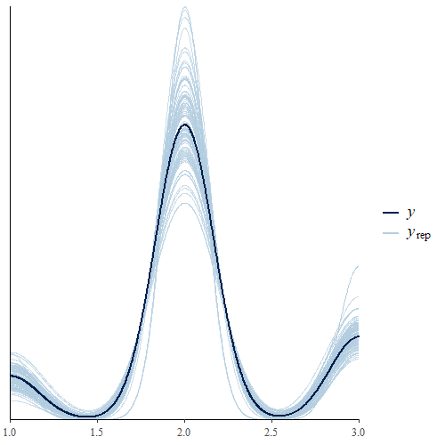

**Supplementary Figure 25.**Need for Less/Same/More Surveillance Model Plot: Observed data (dark blue line) and modelled data (light blue lines).

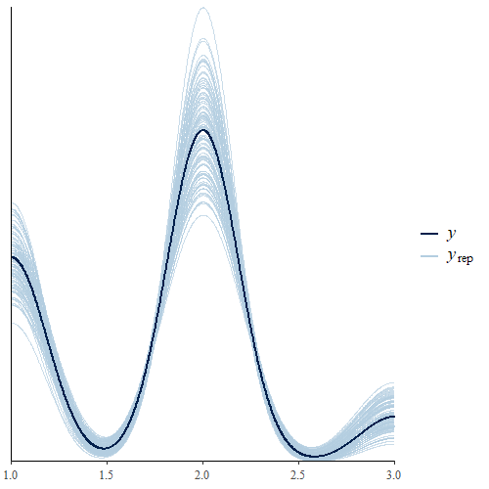

**Supplementary Figure 26.** Inclined to Attend if Surveillance Model Plot: Observed data (dark blue line) and modelled data (light blue lines).

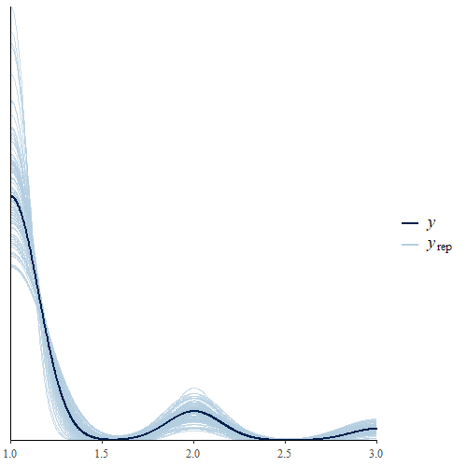

**Supplementary Figure 27.** Declined to Attend due to Feeling Unsafe Model Plot: Observed data (dark blue line) and modelled data (light blue lines).

**PART B: FULL RESULTS**

**Supplementary Table 1.** Full results for all models. Bolded independent factors under main headings have significant results.

|  |  |  |  |  |  |  |
| --- | --- | --- | --- | --- | --- | --- |
|  |  | **Term** | **Est** | **Est.Err** | **CI-2.5%** | **CI-97.5%** |
| **GENERAL SAFETY CONCERNS** |  |  |  |  |  |  |
| **Personal Safety** |  | Intercept[1] | -0.37 | 0.28 | -0.93 | 0.16 |
|  |  | Intercept[2] | 2.74 | 0.43 | 1.98 | 3.63 |
|  |  | **Experience.L** | -0.82 | 0.29 | **-1.37** | **-0.23** |
|  |  | Experience.Q | -0.22 | 0.28 | -0.78 | 0.32 |
|  |  | **SexMale** | -1.51 | 0.34 | **-2.18** | **-0.85** |
|  |  | SexOrientLGBQA | 0.26 | 0.41 | -0.54 | 1.05 |
| **Changes in Personal Safety** |  | Intercept[1] | -4.22 | 0.54 | -5.34 | -3.19 |
|  |  | Intercept[2] | 0.48 | 0.26 | -0.03 | 0.98 |
|  |  | Intercept[3] | 1.00 | 0.28 | 0.46 | 1.52 |
|  |  | Experience.L | -0.39 | 0.29 | -0.95 | 0.18 |
|  |  | Experience.Q | -0.23 | 0.27 | -0.78 | 0.29 |
|  |  | SexMale | -0.51 | 0.32 | -1.16 | 0.11 |
|  |  | SexOrientLGBQA | -0.45 | 0.44 | -1.34 | 0.39 |
| **SPECIFIC SAFETY CONCERNS** | % Pop |  |  |  |  |  |
| **Physical** | 23% | (Intercept) | -0.88 | 0.29 | -1.46 | -0.33 |
|  |  | SexMale | -0.57 | 0.36 | -1.28 | 0.14 |
|  |  | **Experience.L** | -0.61 | 0.30 | **-1.21** | **-0.01** |
|  |  | Experience.Q | 0.23 | 0.31 | -0.36 | 0.85 |
|  |  | SexOrientLGBQA | 0.21 | 0.44 | -0.68 | 1.05 |
| **Crowd Violence** | 37% | (Intercept) | 0.04 | 0.26 | -0.46 | 0.56 |
|  |  | **SexMale** | -0.90 | 0.32 | **-1.53** | **-0.28** |
|  |  | **Experience.L** | -0.61 | 0.28 | **-1.17** | **-0.06** |
|  |  | Experience.Q | -0.23 | 0.27 | -0.75 | 0.30 |
|  |  | SexOrientLGBQA | 0.04 | 0.41 | -0.77 | 0.83 |
| **Sexual** | 33% | (Intercept) | 0.32 | 0.27 | -0.19 | 0.85 |
|  |  | **SexMale** | -2.09 | 0.36 | **-2.81** | **-1.40** |
|  |  | Experience.L | -0.49 | 0.32 | -1.12 | 0.14 |
|  |  | Experience.Q | 0.12 | 0.31 | -0.47 | 0.73 |
|  |  | SexOrientLGBQA | 0.23 | 0.44 | -0.64 | 1.09 |
| **Terrorism** | 23% | (Intercept) | -0.85 | 0.28 | -1.41 | -0.32 |
|  |  | **SexMale** | -1.12 | 0.37 | **-1.86** | **-0.41** |
|  |  | Experience.L | 0.02 | 0.33 | -0.61 | 0.70 |
|  |  | Experience.Q | 0.09 | 0.32 | -0.53 | 0.73 |
|  |  | **SexOrientLGBQA** | 0.88 | 0.42 | **0.05** | **1.69** |
| Police | 30% | (Intercept) | -1.07 | 0.29 | -1.65 | -0.52 |
|  |  | SexMale | -0.01 | 0.34 | -0.67 | 0.66 |
|  |  | Experience.L | 0.19 | 0.29 | -0.37 | 0.79 |
|  |  | Experience.Q | 0.36 | 0.30 | -0.22 | 0.97 |
|  |  | SexOrientLGBQA | 0.48 | 0.41 | -0.34 | 1.27 |
| Unwanted Security | 46% | (Intercept) | -0.40 | 0.26 | -0.92 | 0.10 |
|  |  | SexMale | 0.14 | 0.30 | -0.45 | 0.74 |
|  |  | Experience.L | 0.40 | 0.27 | -0.13 | 0.94 |
|  |  | Experience.Q | 0.05 | 0.26 | -0.46 | 0.56 |
|  |  | SexOrientLGBQA | 0.34 | 0.39 | -0.41 | 1.11 |
| **MEASURES** |  |  |  |  |  |  |
| Location | 43% | (Intercept) | -0.52 | 0.26 | -1.04 | -0.01 |
|  |  | SexMale | 0.26 | 0.31 | -0.34 | 0.87 |
|  |  | Experience.L | -0.17 | 0.27 | -0.69 | 0.36 |
|  |  | Experience.Q | 0.02 | 0.26 | -0.49 | 0.54 |
|  |  | SexOrientLGBQA | 0.54 | 0.38 | -0.21 | 1.30 |
| Ethos/Vibe | 87% | (Intercept) | 1.77 | 0.38 | 1.08 | 2.57 |
|  |  | SexMale | 0.02 | 0.45 | -0.88 | 0.88 |
|  |  | Experience.L | 0.12 | 0.45 | -0.85 | 0.97 |
|  |  | Experience.Q | 0.80 | 0.37 | 0.09 | 1.53 |
|  |  | SexOrientLGBQA | 1.13 | 0.78 | -0.20 | 3.01 |
| **Police** | 25% | (Intercept) | -0.61 | 0.28 | -1.16 | -0.08 |
|  |  | **SexMale** | -0.68 | 0.35 | **-1.37** | **-0.01** |
|  |  | Experience.L | 0.00 | 0.30 | -0.57 | 0.60 |
|  |  | Experience.Q | 0.56 | 0.32 | -0.04 | 1.22 |
|  |  | SexOrientLGBQA | -0.64 | 0.48 | -1.65 | 0.26 |
| **Surveillance** | 21% | (Intercept) | -0.76 | 0.28 | -1.32 | -0.23 |
|  |  | **SexMale** | -0.96 | 0.36 | **-1.68** | **-0.26** |
|  |  | Experience.L | -0.27 | 0.33 | -0.91 | 0.39 |
|  |  | Experience.Q | -0.30 | 0.30 | -0.89 | 0.29 |
|  |  | SexOrientLGBQA | 0.37 | 0.43 | -0.50 | 1.20 |
| Private Security | 19% | (Intercept) | -1.33 | 0.31 | -1.97 | -0.75 |
|  |  | SexMale | -0.41 | 0.38 | -1.15 | 0.34 |
|  |  | Experience.L | 0.34 | 0.35 | -0.32 | 1.06 |
|  |  | Experience.Q | 0.26 | 0.35 | -0.41 | 0.97 |
|  |  | SexOrientLGBQA | 0.19 | 0.47 | -0.77 | 1.08 |
| **Citizen Security** | 41% | (Intercept) | -0.29 | 0.26 | -0.80 | 0.22 |
|  |  | SexMale | -0.24 | 0.31 | -0.85 | 0.37 |
|  |  | **Experience.L** | **-0.39** | **0.27** | **-0.92** | **0.14** |
|  |  | Experience.Q | 0.50 | 0.27 | -0.03 | 1.04 |
|  |  | SexOrientLGBQA | 0.48 | 0.39 | -0.28 | 1.25 |
| **Friends** | 61% | (Intercept) | 0.82 | 0.27 | 0.29 | 1.37 |
|  |  | **SexMale** | **-0.75** | **0.32** | **-1.38** | **-0.13** |
|  |  | Experience.L | -0.43 | 0.29 | -1.00 | 0.12 |
|  |  | Experience.Q | -0.06 | 0.28 | -0.60 | 0.48 |
|  |  | SexOrientLGBQA | 0.63 | 0.43 | -0.20 | 1.52 |
| Health Tents | 62% | (Intercept) | 0.72 | 0.27 | 0.20 | 1.26 |
|  |  | SexMale | -0.51 | 0.32 | -1.14 | 0.10 |
|  |  | Experience.L | 0.11 | 0.28 | -0.43 | 0.65 |
|  |  | Experience.Q | 0.22 | 0.26 | -0.30 | 0.74 |
|  |  | SexOrientLGBQA | 0.16 | 0.40 | -0.62 | 0.97 |
| **FEELINGS** |  |  |  |  |  |  |
| **Safe** | 34% | (Intercept) | -0.10 | 0.26 | -0.61 | 0.41 |
|  |  | **SexMale** | -0.66 | 0.32 | **-1.29** | **-0.03** |
|  |  | **Experience.L** | -0.60 | 0.28 | **-1.15** | **-0.06** |
|  |  | Experience.Q | 0.13 | 0.27 | -0.40 | 0.67 |
|  |  | SexOrientLGBQA | -0.40 | 0.42 | -1.26 | 0.40 |
| Indifferent | 30% | (Intercept) | -0.84 | 0.28 | -1.41 | -0.31 |
|  |  | SexMale | 0.31 | 0.33 | -0.33 | 0.96 |
|  |  | Experience.L | -0.28 | 0.28 | -0.82 | 0.28 |
|  |  | Experience.Q | 0.23 | 0.28 | -0.31 | 0.79 |
|  |  | SexOrientLGBQA | -0.38 | 0.44 | -1.28 | 0.44 |
| **Changes Vibe** | 56% | (Intercept) | -0.40 | 0.26 | -0.92 | 0.12 |
|  |  | SexMale | 0.59 | 0.32 | -0.02 | 1.21 |
|  |  | **Experience.L** | 0.59 | 0.28 | **0.05** | **1.15** |
|  |  | Experience.Q | -0.38 | 0.27 | -0.92 | 0.14 |
|  |  | **SexOrientLGBQA** | 1.20 | 0.44 | **0.37** | **2.12** |
| Watched | 24% | (Intercept) | -0.40 | 0.26 | -0.92 | 0.10 |
|  |  | SexMale | 0.01 | 0.30 | -0.59 | 0.61 |
|  |  | Experience.L | 0.35 | 0.27 | -0.18 | 0.90 |
|  |  | Experience.Q | 0.01 | 0.26 | -0.50 | 0.53 |
|  |  | SexOrientLGBQA | 0.17 | 0.39 | -0.60 | 0.92 |
| Anxious | 44% | (Intercept) | -1.34 | 0.31 | -1.97 | -0.77 |
|  |  | SexMale | -0.06 | 0.36 | -0.76 | 0.67 |
|  |  | Experience.L | 0.02 | 0.32 | -0.59 | 0.66 |
|  |  | Experience.Q | 0.13 | 0.32 | -0.48 | 0.76 |
|  |  | SexOrientLGBQA | 0.54 | 0.43 | -0.33 | 1.36 |
| At Risk | 27% | (Intercept) | -0.98 | 0.28 | -1.55 | -0.44 |
|  |  | SexMale | -0.52 | 0.34 | -1.20 | 0.16 |
|  |  | Experience.L | 0.37 | 0.32 | -0.23 | 1.02 |
|  |  | Experience.Q | 0.25 | 0.31 | -0.35 | 0.88 |
|  |  | SexOrientLGBQA | 0.69 | 0.41 | -0.12 | 1.48 |
| **SURVEILLANCE** |  |  |  |  |  |  |
| Notice Survillance |  | Intercept[1] | -1.65 | 0.29 | -2.23 | -1.10 |
|  |  | Intercept[2] | 1.44 | 0.29 | 0.90 | 2.03 |
|  |  | SexMale | -0.16 | 0.31 | -0.76 | 0.43 |
|  |  | Experience.L | 0.26 | 0.27 | -0.27 | 0.79 |
|  |  | Experience.Q | 0.26 | 0.26 | -0.23 | 0.76 |
|  |  | SexOrientLGBQA | 0.24 | 0.40 | -0.55 | 1.04 |
| **Notice Changes in Survillance** |  | (Intercept) | -0.22 | 0.26 | -0.73 | 0.28 |
|  |  | SexMale | 0.28 | 0.31 | -0.32 | 0.89 |
|  |  | **Experience.L** | 0.62 | 0.28 | **0.09** | **1.18** |
|  |  | Experience.Q | -0.02 | 0.26 | -0.54 | 0.49 |
|  |  | SexOrientLGBQA | 0.39 | 0.40 | -0.38 | 1.19 |
| **Need More/Less Surveillance** |  | Intercept[1] | -2.94 | 0.36 | **-3.68** | **-2.24** |
|  |  | Intercept[2] | 0.85 | 0.27 | 0.33 | 1.39 |
|  |  | **SexMale** | -0.86 | 0.33 | **-1.51** | **-0.24** |
|  |  | Experience.L | -0.44 | 0.28 | -0.99 | 0.11 |
|  |  | Experience.Q | -0.05 | 0.27 | -0.58 | 0.48 |
|  |  | SexOrientLGBQA | -0.23 | 0.41 | -1.02 | 0.55 |
| **Surveillance/Inclined** |  | Intercept[1] | -1.23 | 0.28 | -1.78 | -0.70 |
|  |  | Intercept[2] | 1.99 | 0.32 | 1.39 | 2.62 |
|  |  | SexMale | -0.60 | 0.31 | -1.21 | 0.01 |
|  |  | **Experience.L** | -0.61 | 0.27 | **-1.14** | **-0.07** |
|  |  | Experience.Q | 0.01 | 0.25 | -0.48 | 0.50 |
|  |  | SexOrientLGBQA | -0.50 | 0.38 | -1.23 | 0.22 |
| **Unsafe/Declined** |  | Intercept[1] | 1.19 | 0.32 | 0.59 | 1.82 |
|  |  | Intercept[2] | 2.63 | 0.43 | 1.83 | 3.49 |
|  |  | **SexMale** | -1.21 | 0.45 | **-2.11** | **-0.32** |
|  |  | Experience.L | -0.15 | 0.41 | -0.95 | 0.64 |
|  |  | Experience.Q | -0.12 | 0.37 | -0.84 | 0.61 |
|  |  | SexOrientLGBQA | 0.00 | 0.56 | -1.14 | 1.04 |

**References**

Bürkner, P.-C. 2018. Advanced Bayesian multilevel modeling with the R Package brms. *The R Journal* 10(1): 395–411. doi: 10.32614/RJ-2018-017.

Lüdecke D, Ben-Shachar MS, Patil, I, Waggoner P, and Makowski D. 2020. Visualisation Toolbox for ‘easystats’ and extra geoms, themes and color palettes for ‘ggplot2’. CRAN. Available from <https://easystats.github.io/see/>